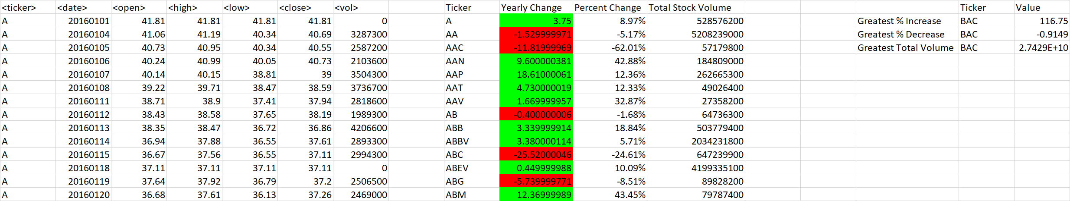

(Year 2016)

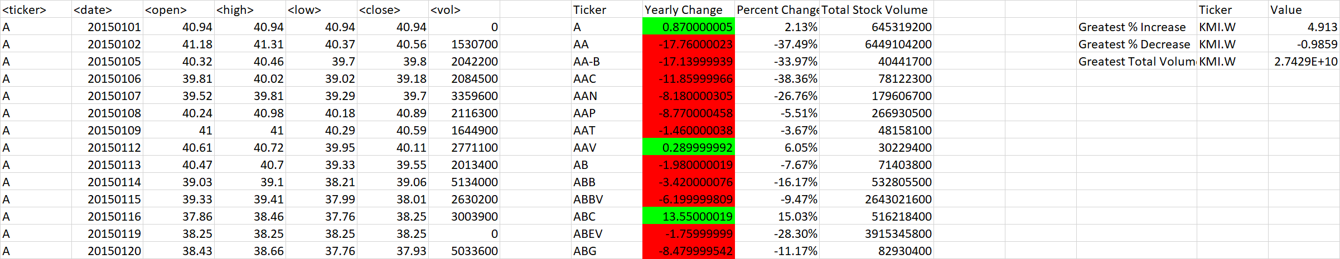

(Year 2015)

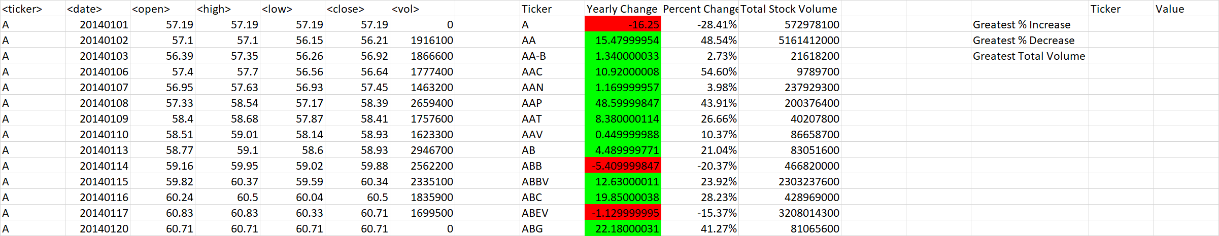

(Year 2014)